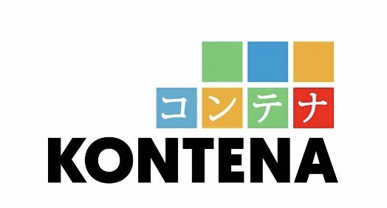

To.

Sdri. ...................................

Dear ......................,

On behalf of the Management Kontena Hotel/PT.Graha Mitra Indonesia, I am pleased to advice you that starting .................... you salary will be increased:

Your new income will be Rp. .......................(Gross)

Basic Salary : Rp. ................... (Gross)
HP Allowance : Rp.................... (Gross)

I would like to take this opportunity to thank you for your enthusiasm and hard work and wish you every success for your future with Kontena Hotel.

Yours Sincerely,

Michael Setiawan
Hotel Manager

cc. - HRD Manager
- Chief Accountant

